CLC - Project 1: Lexical Analyzer

By Christoffer Hansen & Emma Schaffner
College of Engineering and Technology, Grand Canyon University
CST-410 Game Design and Game Play Lecture & Lab
Dr. Artzi

- Evidence of access to Unix/Linux.
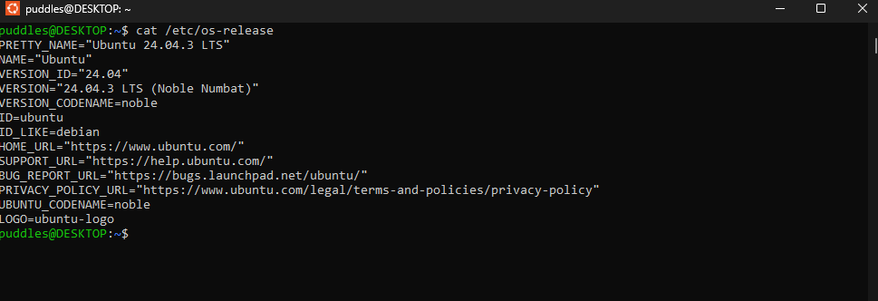
- Evidence of proper installation of Flex and Bison.
